**GUI Testing**

1. URL:

The frontend is hosted on localhost: 3000.

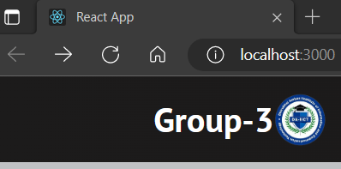

1. Home Page:

It gives a brief introduction on Speed Detection. By clicking on “Group-3” we will be directed to the home page irrespective of which page we are on.

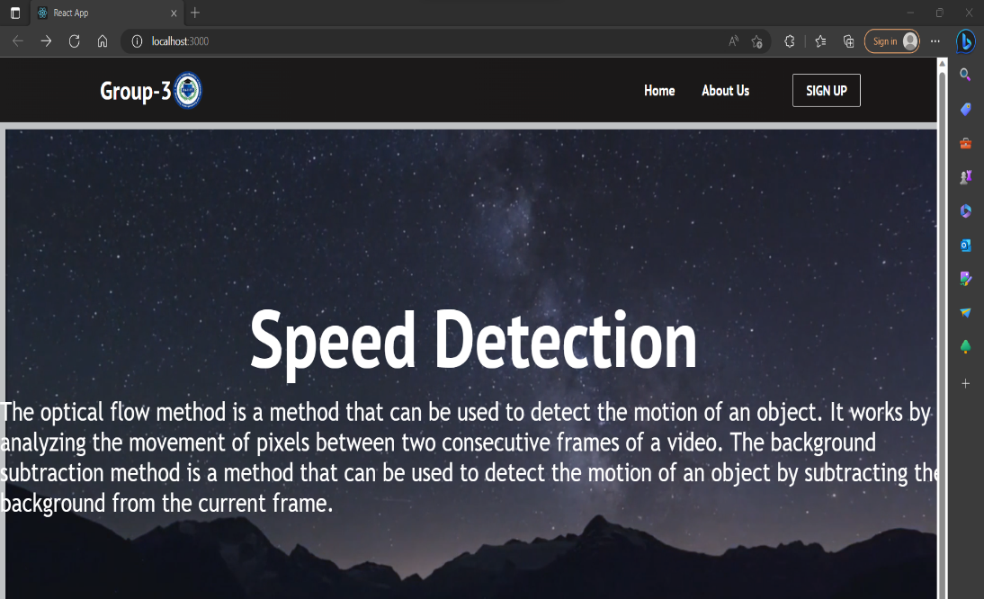

1. Navbar:

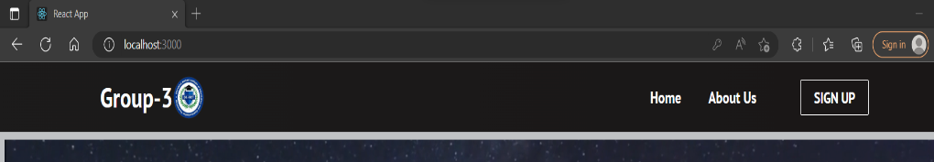

1. About us:



1. Login:

We need correct email and password to log into the site and upload our file. It has the functionality of forgot password but it is currently not working. If we don’t have an account, we can ‘signup’ as well by clicking on the link which will direct us to the signup page.

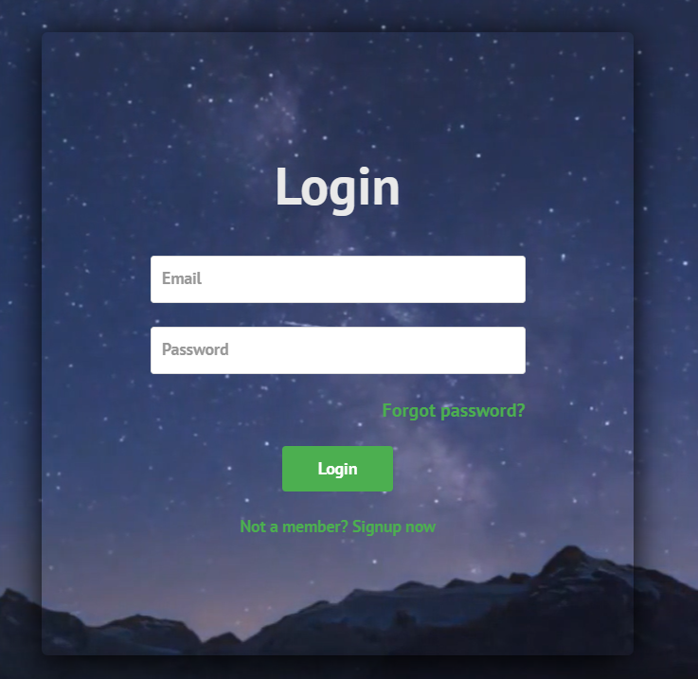

1. Login Success:

Here with valid credentials, when logged in, local host says that the login is successful and now I can upload video file. By clicking on OK we will be directed to the upload file page where we can upload video file.

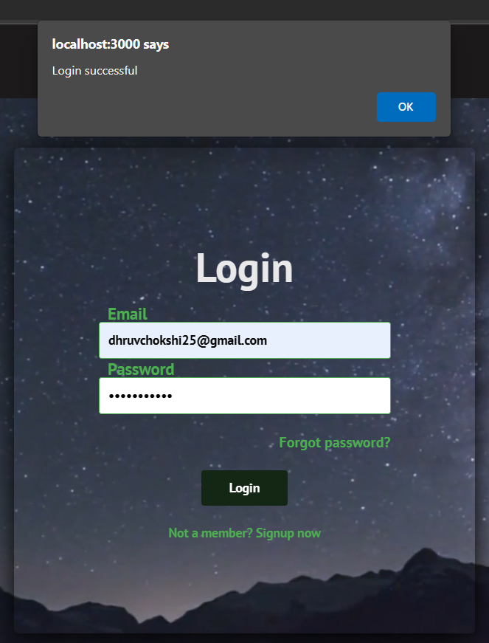

1. Login fail:

Here in both the images, we can see that there is an error in logging in as there was invalid email and incorrect password respectively. After clicking on OK we can again try logging in.

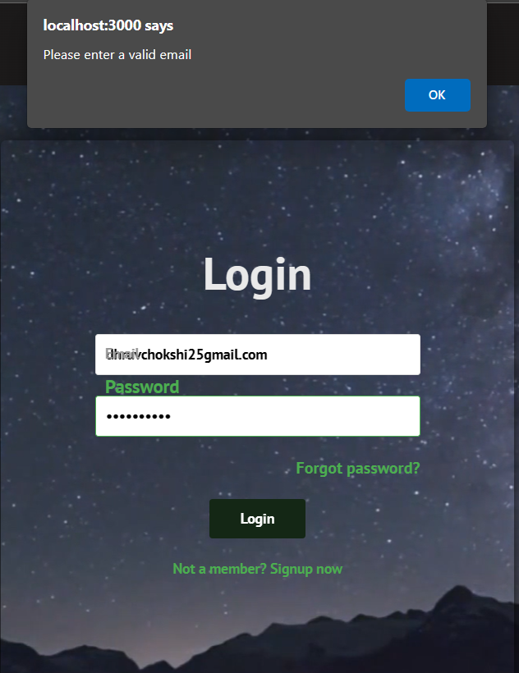

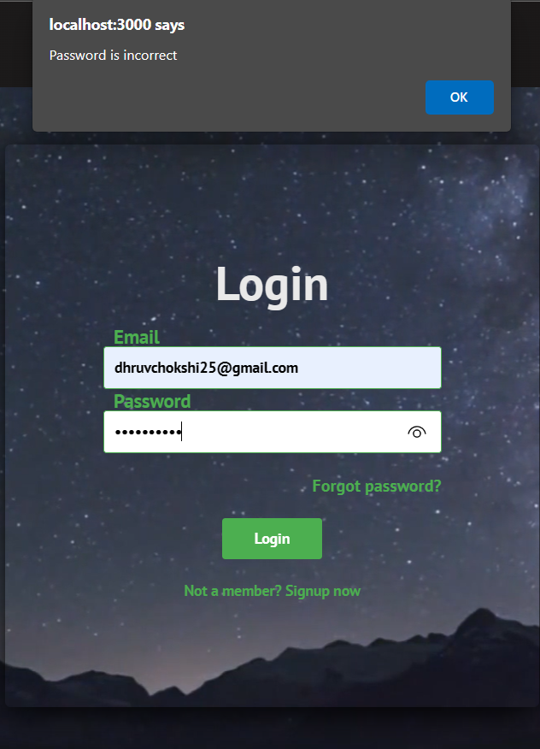

1. Signup:

Here you can see, in order to create an account, you need an email and a valid password. Once you create your account, you will be directed to Login page where you will be able to login and upload video file.

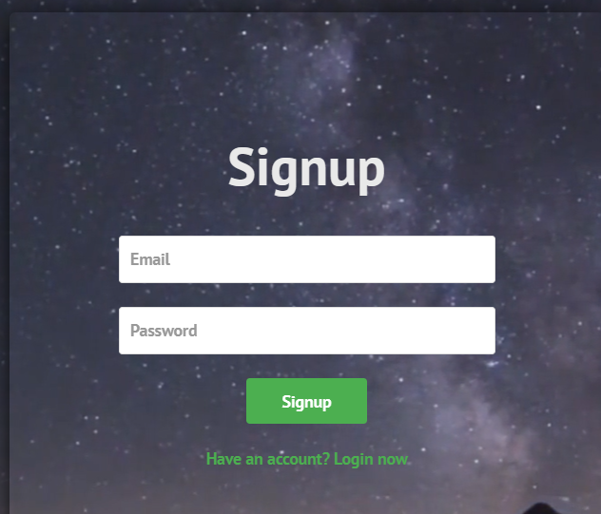

1. Signup Success:

For successful signup, you need valid and password. Once signed in, your account will be created.

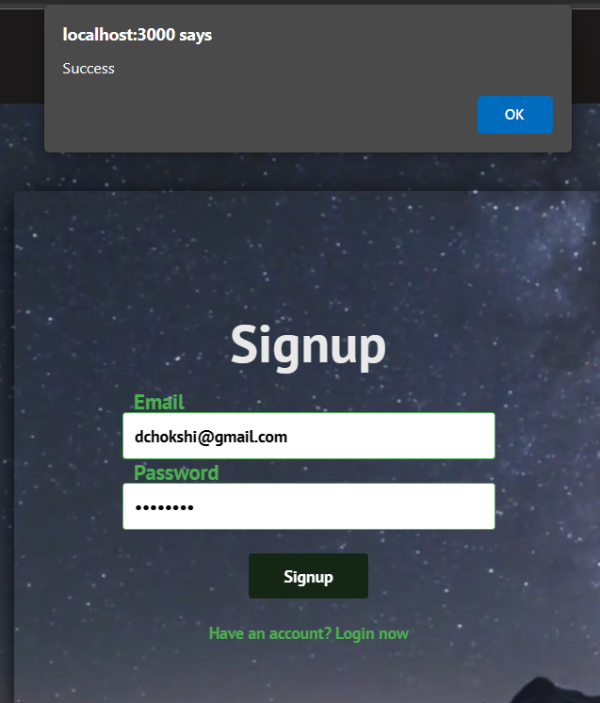

1. Invalid Signup:

Here due to invalid email, we are unable to signup, since @ is not there in email.

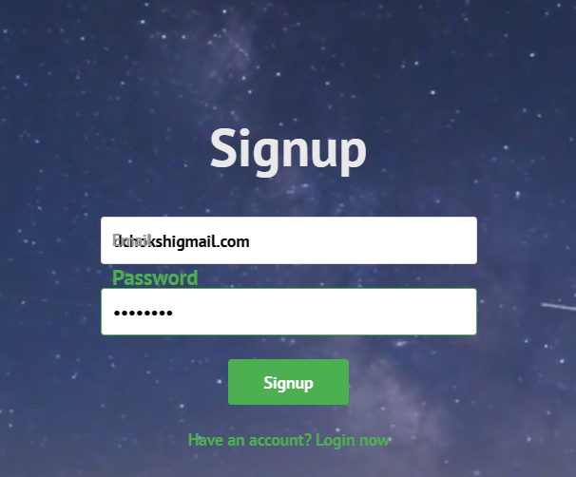

1. Upload page:

We will be directed on this page once we login.

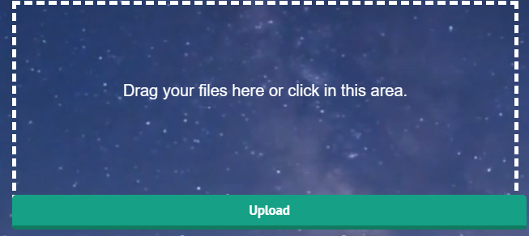

1. Working Upload:

Once we click in the area given, we will be able to upload as shown in the image.

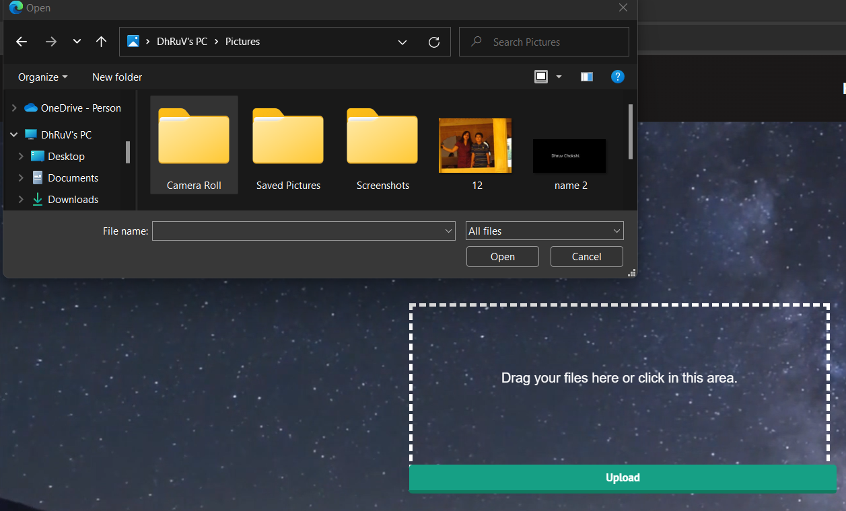

1. Uploaded Video:

When we select a video for speed testing, it gets uploaded in the mp4 form.

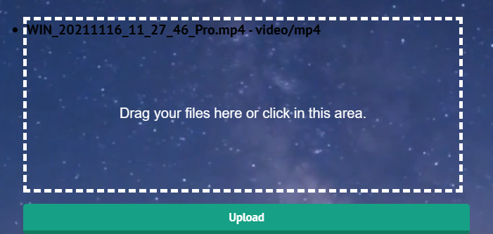

1. History Page:

Here we can see the accounts of those people who have done speed testing. To login with another account we need to logout.

